**1. What is the use of the git add command?  
Ans**. The git add command is used to stage the changes that need to be included in the next commit.

**2. Write the command to create a branch “feature-group”.  
Ans.** git branch feature-group

**3. What is a pull request? Write the steps involved in creating a pull request.  
Ans.** Pull request is a way to ask the owner of a repository to merge your changes (from a separate branch) into their main codebase.  
Steps:- Push your branch → Go to GitHub → Click “Compare & pull request” → Add title/description → Click “Create pull request”.

**4. How do you add collaborators?  
Ans.** We will first go to our repository on GitHub, then Click on **Settings** and click on **Collaborators** under **Access** section. Click **Add collaborator** and enter the username.

**5. What is the command used to commit our changes in GitHub repo?  
Ans.** git commit -m "Commit message"

**6. Create a github account and repository to save all your assignment tasks. Example repository name: rg-assignments**

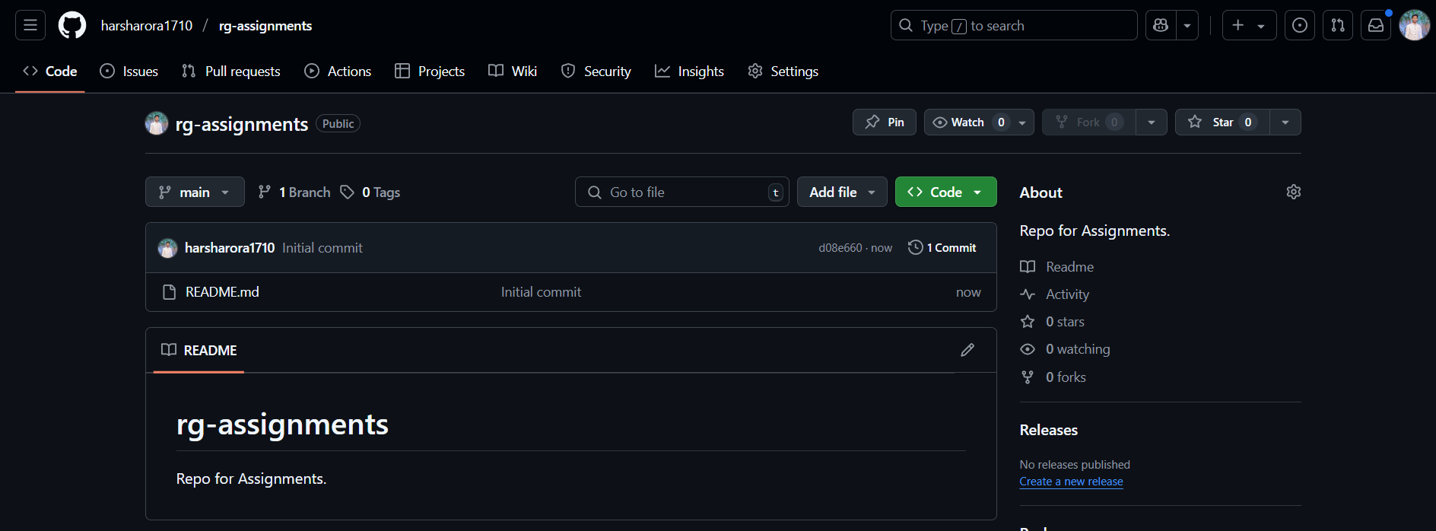

**7. Create a branch called feature-java(you can use it later to push all your java related tasks to this branch)**

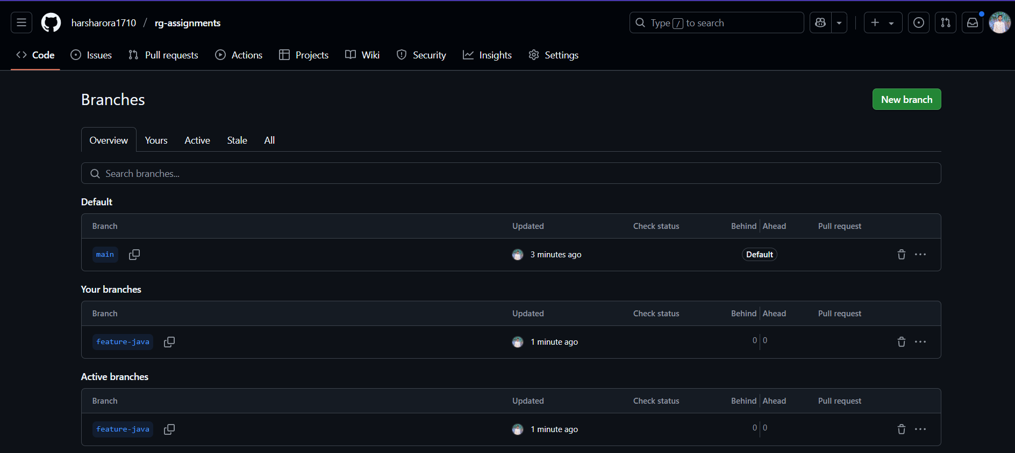

**8. Install IntelliJ IDE. Create a simple java project displaying “Hello World!!”and share the screenshot.**

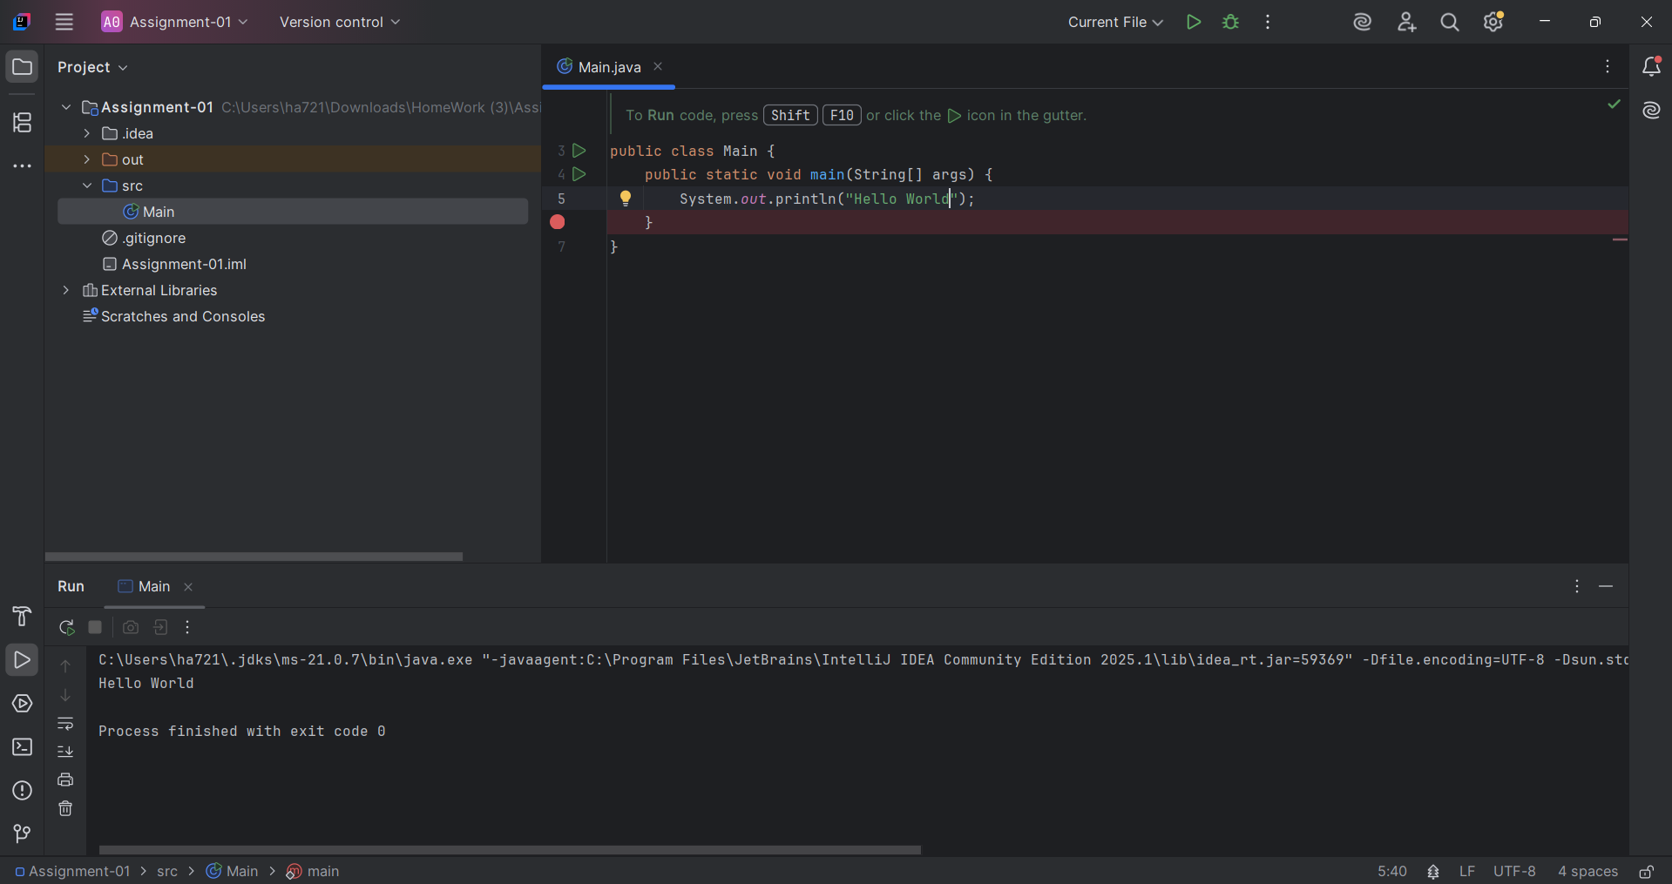

**9. In IntelliJ IDE, explore the shortcut keys for the following**

**To run the project** Shift + F10

**To select a line** Home then Shift + End

**To comment/uncomment a line** Ctrl + /

**To delete a line** Ctrl + Y